Vendor Performance Analysis

Business Problem
Effective inventory and sales management are critical for optimizing profitability in the retail and wholesale industry. Companies need to ensure that they are not incurring losses due to inefficient pricing, poor inventory turnover, or vendor dependency. The goal of this analysis is to:
● Identify underperforming brands that require promotional or pricing adjustments.
● Determine top vendors contributing to sales and gross profit.
● Analyze the impact of bulk purchasing on unit costs.
● Assess inventory turnover to reduce holding costs and improve efficiency.
● Investigate the profitability variance between high-performing and low-performing vendors.

2. Dataset Description
The dataset was extracted from the vendor_sales_summary table in SQL Server and contains information on:
- Vendor Name
- Brand Description
- Total Sales & Purchases
- Gross Profit
- Profit Margin
- Stock Turnover
- Purchase Price
- Freight Cost
- Tax Amount
- Sales & Purchase Quantity
After initial inspection, records with negative profit, zero sales, and inconsistencies were removed for better analysis quality.

3. Tools & Technologies
Tool | Purpose
SQL Server | Data Storage
Python (Pandas, Matplotlib, Seaborn) | Data Cleaning & Analysis
Power BI | Dashboard & Visualization
Jupyter Notebook | Exploratory Analysis

4. Data Preparation & Cleaning
Steps Performed:
- Connected to SQL Server using SQLAlchemy
- Removed records with:
  - Negative Gross Profit
  - Negative Profit Margin
  - Zero Sales Quantity
- Created derived metrics:
  - Unit Purchase Price
  - Unsold Inventory Value
  - Purchase Contribution %
  - Order Size Categories
This ensured only reliable and meaningful data was used.

5. Exploratory Data Analysis (EDA)
Summary Statistics
5.1 Distribution Analysis
Histograms and boxplots were used to understand data spread and detect outliers.
Findings:
- Some products had extremely high prices (premium brands)
- Freight cost showed high variability
- Stock turnover ranged from very low to extremely high

5.2 Correlation Analysis

Purchase Price vs. Total Sales Dollars & Gross Profit: Weak correlation (-0.012 and -0.016), indicating that price variations do not significantly impact sales revenue or profit.
Total Purchase Quantity vs. Total Sales Quantity: Strong correlation (0.999), confirming efficient inventory turnover.
Profit Margin vs. Total Sales Price: Negative correlation (-0.179), suggesting increasing sales prices may lead to reduced margins, possibly due to competitive pricing pressures.
Stock Turnover vs. Gross Profit & Profit Margin: Weak negative correlation (-0.038 & -0.055), indicating that faster stock turnover does not necessarily equate to higher profitability.

Research Questions & Key Findings
- Brands for Promotional or Pricing Adjustments

- Brands with:
- Bottom 15% sales
- Top 15% profit margin
were identified as Target Brands for promotion.
These brands are profitable but underperforming in volume.
Business Meaning:
These products have strong margins and can generate more profit if sales volume increases.

2. Top Vendors by Sales & Purchase Contribution
The top 10 vendors contribute 65.69% of total purchases, while the remaining vendors contribute only 34.31%. This over-reliance on a few vendors may introduce risks such as supply chain disruptions, indicating a need for diversification

3. Impact of Bulk Purchasing on Cost Savings
Vendors buying in large quantities receive a 72% lower unit cost ($10.78 per unit vs. higher unit costs in smaller orders).
Bulk pricing strategies encourage larger orders, increasing total sales while maintaining profitability.

4. Identifying Vendors with Low Inventory Turnover
Total Unsold Inventory Capital: $2.71M
Slow-moving inventory increases storage costs, reduces cash flow efficiency, and affects overall profitability.
Identifying vendors with low inventory turnover enables better stock management, minimizing financial strain

5. Power BI Dashboard Design
Finally, we built an interactive dashboard in Power BI to present insights visually.
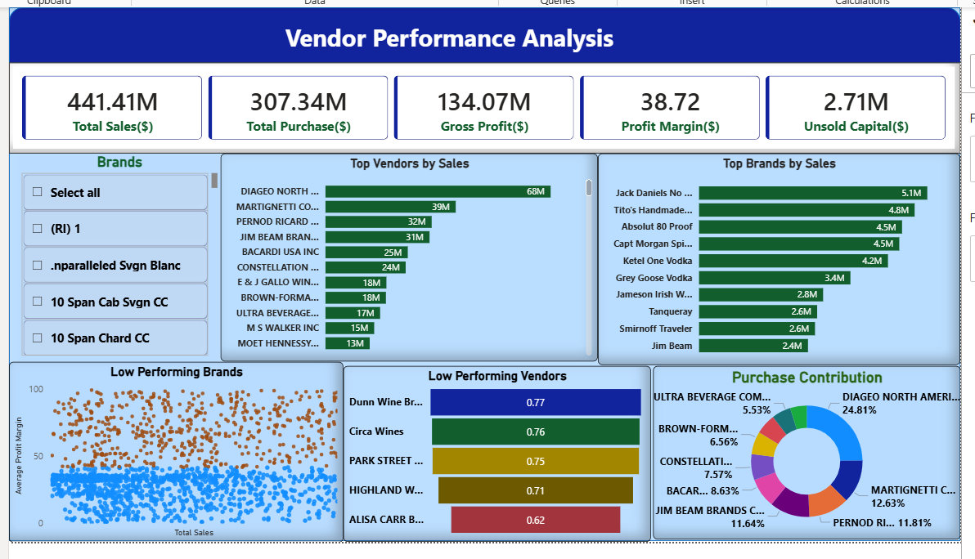

9. Business Recommendations
9.1 Promote High-Margin Brands
Target Brands should be:
- Included in discounts
- Featured in promotions
- Bundled with popular products
Expected Impact:
Increase revenue without reducing margins.

9.2 Reduce Vendor Dependency
- Diversify procurement sources
- Develop secondary suppliers
- Renegotiate contracts
This reduces operational risk.

9.3 Optimize Inventory Management
For low turnover vendors:
- Reduce purchase quantity
- Apply clearance discounts
- Review demand forecasts
This will free locked capital.

9.4 Expand Bulk Purchasing Strategically
For fast-moving products:
- Increase order size
- Negotiate volume discounts
But avoid bulk buying for slow products.

9.5 Improve Pricing Strategy
- Re-evaluate low-margin products
- Adjust pricing based on demand
- Control freight and logistics costs

